Foresight for the Integration of MEDA Partners into the European Research Area (www.innformed.org)
- What was the motivation to start doing Foresight in the first place? What was the key problem driving the launching of the exercise?

The INNFORMED (Innovation Foresight for MEDA Partners in the ERA) project was set up to increase the use of participative foresight approaches in support of joint efforts of the European Union and Mediterranean Partners in developing strategic approaches to the development of the innovation systems of partner countries and thus opening up the European Research Area to the Mediterranean. INNFORMED combined the use of Innovation Systems thinking and a foresight approach to develop a structured Euro-Med dialogue in research and innovation, to embed innovation systems thinking in the region, to deepen and strengthen MEDA capabilities in RTDI related policy process design and implementation, and develop success scenarios for turning current MEDA strengths and RTD investments into growth opportunities.
The project sought to strengthen RTD and Innovation (RTDI) policy development processes in the non-EU MEDA partners through the use of foresight for the integration of national RTDI systems with the ERA. It was carried out in cooperation with teams based in four countries (Tunisia, Morocco, Jordan and Egypt), and efforts were made to disseminate learning benefits to other members of the group. INNFORMED also involved the MoCo in a strategic consultative capacity drew upon other policy-related initiatives such as the complementary FP6-INCO ESTIME project.
- What were the objectives of the Foresight exercise?
The specific objectives were:
- To use a combination of Innovation Systems thinking and foresight approaches as the basis for developing a structured dialogue in research and innovation between the EU and the Mediterranean, thereby facilitating the opening up of the ERA to the Mediterranean.
- To embed in the non-EU MEDA partner countries innovation systems thinking and a broader-based foresight capability at the policy design and implementation levels by identifying and developing capabilities in a network of foresight and RTDI experts and key stakeholder organisations in the national RTDI system.
- To facilitate and support the work of local experts and stakeholders in pilot exercises for the development of success scenarios for exploiting and turning the country’s current/potential strengths and investments in RTD into economic opportunities.
In summary the objectives were:
- Reinforce a systemic approach to R+I policies
- Introduce relevant Foresight tools and techniques
  - Success Scenarios
  - Road-mapping
- Implement two pilots in each partner country
  - Technical Foresight
  - Structural Foresight
- Encourage networking of experts with experience in application of such tools
- Produce a publication on Mediterranean Foresight
- How was the exercise designed? Implementation would take place over a 24 month period (in fact an extension of the Project was required to complete the work). Innformed was originally designed to follow three main Phases:
Phase 1 consultation with MoCo members would help to identify appropriate national experts and a round of scoping (exercises) visits would be made to prioritise aspects of the innovation system of the three partner countries suitable for development through foresight activity.
A Programme Design Workshop would launch Phase 2. Experts from the other non-EU MEDA countries – Algeria, Lebanon, Syria and the Palestinian Authority would be invited to attend Phase 2 would involve the design of pilot foresight programmes. These would be executed in Phase 3.
In Phase 3, work would involve the execution of background analyses and the development of input scenarios to support ‘success scenario workshops’ in Egypt, Jordan, Tunisia and Morocco. Experts from the four partner countries with support from the consortium would take the lead in preparing the necessary background analyses and input scenarios to support the success scenario workshops (based on interviews with local stakeholders). These workshops would constitute the centrepiece of the project. Success scenario methodology has been developed in the United Kingdom and used as a significant input to national policy in ICT, biotechnology and nanotechnology as well as for horizontal policy areas such as university-industry linkages and policy for FP7. Four success scenario workshops would be held, one in each of the participating countries. They would bring together the key stakeholders in the national innovation system to develop visions of what success would like in key aspects of those systems and to create an actionable plan for the development of the national innovation systems in the form of a roadmap. Following these workshops Reports would be prepared on the outcomes. A manual would be prepared to provide methodological guidance for others in the region that want to pursue this approach.
A dissemination event would involve key stakeholders and potential EU partners to form a basis for future participation in the FP and ERA. Dissemination would also take the form of reports on the workshop outcomes and a manual to support the take-up of these techniques in the region. It would be carried out via a dedicated mailing list and a dissemination event that would provide a basis for further cooperation in the FP and the ERA.

.

  - Was there a team, external support?
The Project team provided the support. Overall management and coordination was undertaken by CKA. However, technical responsibility for the project would be shared among the partners, with UNIMAN providing scientific coordination and MCST being responsible for policy coordination. The partners (MoCo and national experts) would form a management committee to deal with collective administrative issues.

To implement the project in each country a national expert would be contracted to undertake a coordinating role with support from the EU partners. The profile for the experts was as follows: recognized senior scientists (STI policy practitioner), fluent in English, well-connected in their field both on a national and international level. They should have an in-depth knowledge of the national STI system as well as key stakeholder organizations and contacts therein. Candidates would be proposed by the MoCo members, the services of the Commission on the basis of previous INCO-Med experiences, and any other representative and thematic responsible national body of the Mediterranean Countries. The final selection would be made in consultation with MOCO representatives and the Commission. A group of experts based on MOCO members with the addition of domain specialists, would undertake an advisory role for the project to ensure good communication with key officials and people involved in policy development for STI and RTDI as well as the higher education system in the eight non-associated MEDA partners.

  - Was the client involved in the design?
Yes as indicated above, the Euro-Med Monitoring Committee for RTD and Commission services would be consulted on the design.
- What were the key formal methods that were used?
The core methodological approaches of the project were success scenarios and technology roadmapping. These were underpinned by a national systems of innovation perspective.
The success scenario approach has been developed by teams based in Manchester, and focusing on issues of RTDI policy. It has been used to develop UK policy at the highest level in Information and Communication Technologies, Biotechnology and Nanotechnology . More recently the methodology has been extended to consider the future for structural innovation policy issues such as university-industry linkages and policy for FP7.
There are two elements to a success scenario. It combines:
- Desirability. The scenario captures a vision of what could be achieved or aspired to, by the sponsoring organisation or a wider community that it represents.
- Credibility. The scenario is developed with the assistance of, and validated by, a sample of experts in the area, chosen to reflect a broad range of interests (and usually including both practitioners and researchers).

The heart of the process is a scenario workshop; this is supported by background research, and organised in a detailed set of procedures. The background research (normally SWOT or benchmarking analysis) aims to identify a set of sub-domains that can be studied in depth. The benchmarking helps to compare the region, country of organisation with relevant others in the various sub-domains. The comparison should be able to identify trends and dynamics, and the systemic elements of the domain. It should be prepared in such as way as to indicate what informants and available literature suggest might be possible - one way of presenting results in the light of a small set of scenarios for the development of the domain. This provides the workshop participants with a base against which to frame their own preferred scenario.

The INNFORMED project used the innovation systems approach to structure the scenario building activities. This approach begins with the observation that changes in firms’ innovation environment and the underlying drivers have forced governments to re-evaluate their role in innovation.Currently the role of government is seen mainly as a facilitator - that is a provider of framework conditions conducive for innovation. The new role of governments has made it necessary to find new approaches for innovation policy that can deal with a wide set of framework conditions and complex interactions between different types of actors. The answer has been sought in systemic approaches, which started to be adopted in the early 1990s. The main idea behind the innovation systems approach is to see the firm’s innovation environment as a system of actors, interactions and framework conditions (see Figure 1). The original starting point was to analyse national innovation systems, but in recent years regional innovation systems have also been studied. While originating in Europe this perspective has in recent years also been applied to the MEDA countries, see for example Ghazi and Morad. (2004)

Policies based on the innovation systems approach focus on identifying systemic failures, i.e. weaknesses in the innovation system which can and usually do result in poor performance in innovation. Most European countries currently base their innovation policy on the systemic approach. Several larger regions have also adopted the systemic approach encouraged by European Commission activities.

The current understanding of innovation processes appreciates the complex nature of interactions and the role of networks. On the one hand, this means that each company is facing slightly different challenges and therefore has specific needs related to its innovative activities. On the other hand, policies should emphasise networks and facilitate processes instead of single companies.

How was approached participation?
  - What kind of participants were involved?
For Innformed the issue of linkages in the national research and innovation system formed a key guiding post. The workshops involved participants from research organisations or universities, government and business, who in many cases had not worked together or discussed the issues with each other previously. The workshops brought together typically 20-30 senior experts and stakeholders in the sector including
- business leaders in the sector;
- policymakers; and
- scientific experts.

These were identified as persons who were likely to influence the achievement of the vision in a positive way.

  - How were the participants selected and approached?
The participants were profiled by the project team but actually selected by the national experts in the country.
- How long did the Foresight exercise last?
The project was foreseen to be completed in 24 months but was actually completed in 35 months.
- How much did it cost?
295 K euros
- How was it financed?
It was co-funded by the European Commission (DG Research) through the FP6 Inco E programme and by the project partners.
- What was the management structure?

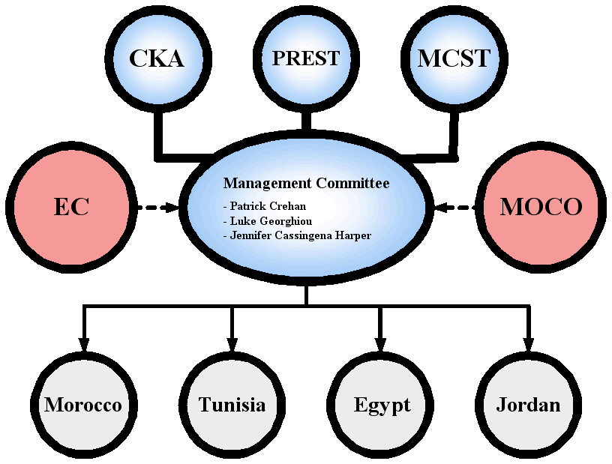

- What were the outcomes (tangible)?
The project introduced the combined use of foresight to improve the functioning of the national research and innovation system in the four targeted countries, namely Egypt, Morocco, Tunisia and Jordan. Key players in these countries were engaged in hands-on success scenario workshops focused on a set of themes identified with the key local entities driving the project.
- What were the benefits (intangible)?
The networks which developed between the partners and the local entities and workshop participants have proven useful in follow-up project such as MIRA.
The results from the success scenario workshops have provided useful insights into the key constraints and bottlenecks affecting innovation systems in the Mediterranean and inform the types of EU support required.
The application of foresight to innovation systems is a highly relevant use of foresight for policy-making and the tools used especially the success scenario approach proved effective.
- What was the main difficulty encountered?
The time constraints were an issue – the project depended on building on existing foresight efforts but it was not easy to do this since they were not always accessible or relevant. Therefore more time was needed to develop the background materials for the exercises.
Working through official agencies is important but in certain cases it involved time and delayed project implementation.
- What was the best experience within the Foresight exercise?
The vibrancy with which the local participants welcomed the project and engaged in the foresight exercise and the important insights they brought to our understanding of the southern Mediterranean innovation systems.
- What should be done differently next time?
To allocate more time to the project setup and implementation
- What was the greatest benefit of the Foresight
It has created an awareness of the importance of foresight approaches in innovation policy development.

Algeria, Egypt, Jordan, Lebanon, Morocco, Palestinian Authority, Tunisia, Syria.
A high level committee of official representatives of EU and Mediterranean Partner countries that monitor Euro-Mediterranean collaboration on RTD and Innovation.
ESTIME stands for ‘Evaluation of Science, Technology and Innovation capabilities in the MEditerranean Countries’.
Ben Saad Ghazi and Diani Morad, Growth and Development in the Euro-Mediterranean Free-Trade Area: The Role of National Systems of Innovation, DRUID Summer Conference 2004: Industrial Dynamics, Innovation and Development

